Instructional Technology Use in the Classroom
Part 1: Training Needs Assessment Report

Canva, Kahoot, ChatGPT

Created By
Mohammadreza Rahimiangolkhandani
Yuhuang Wang

Date

April 2023

Purpose

Professional development (PD) is essential for educators to improve their knowledge, skills, and teaching strategies (Smith, 2020). It keeps them updated with the latest research and technology and motivates them to continue their teaching passion (Brown & Jones, 2019). Regular PD also benefits students by enabling teachers to provide more engaging and practical lessons and personalized learning experiences and fostering a love of learning in the classroom (Garcia & Wei, 2021).

A survey is being conducted by NYIT graduate students to gain insights into how instructional technologies are currently used in classrooms and to understand teachers' technological needs. The goal is to develop a PD workshop that helps educators integrate more instructional technologies into their teaching practices. The study is anonymous, and participants will have access to a summary of the results. The purpose is to gather valuable information to understand the challenges and opportunities associated with implementing instructional technologies in classrooms.

Background
According to the Ministry of Education's requirements in British Columbia, teachers at Westwood School must complete at least 90 professional development hours within a five-year period, with at least 15 hours each year (Ministry of Education, n.d.). To address the instructional technology skills and knowledge gaps among teachers at Westwood Elementary School, a Training Needs Assessment (TNA) was conducted. The survey identified that the teachers at the school need more knowledge and skills in instructional technology integration, particularly in using technology to personalize learning and improve collaboration among students. Survey results recommended a customized training program to enhance teachers' instructional technology skills and knowledge.
In addition to the Ministry of Education's requirements, the International Society for Technology in Education (ISTE) has also set standards for the effective use of technology in education. These standards provide a framework for educators to enhance student learning by leveraging technology in their teaching practices (ISTE, 2021). The training program at Westwood School aligns with the ISTE standards by focusing on developing technology integration skills and promoting personalized and collaborative learning.

This training program aims to provide educators with the technical and pedagogical support to use instructional technologies effectively and introduce the best instructional technology practices relevant to their needs. By doing so, the training program will bridge the gap between the potential benefits of technology and its actual implementation in the classroom at Westwood Elementary School.
The Ministry of Education's requirements in British Columbia, coupled with the results of the TNA, have led to the development of a customized training program for teachers at Westwood School. The training program aims to improve instructional technology integration at the school, providing all students with a quality education regardless of their socio-economic circumstances.

Method
To conduct the Instructional Technologies Survey, we used a Google Form. The survey aimed to gather information on in-service educators' needs regarding technology implementation in teaching. The link to the survey was distributed to participants through different channels via online platforms, such as messaging apps, collaboration apps, and social media pages. Participants were asked to complete the survey at their convenience. The survey consisted of five questions to gather information on the instructional technologies currently used in teaching and the technical and logistical challenges teachers face when trying to improve their instructional technology skills. Participant names and contact information were not collected in order to maintain confidentiality. In the description at the beginning of the survey, participants were informed that their responses would remain anonymous and that the data collected would be used only for research purposes. The survey was administered to around 20 in-service educators teaching across a broad spectrum of grade levels and age ranges.

Result
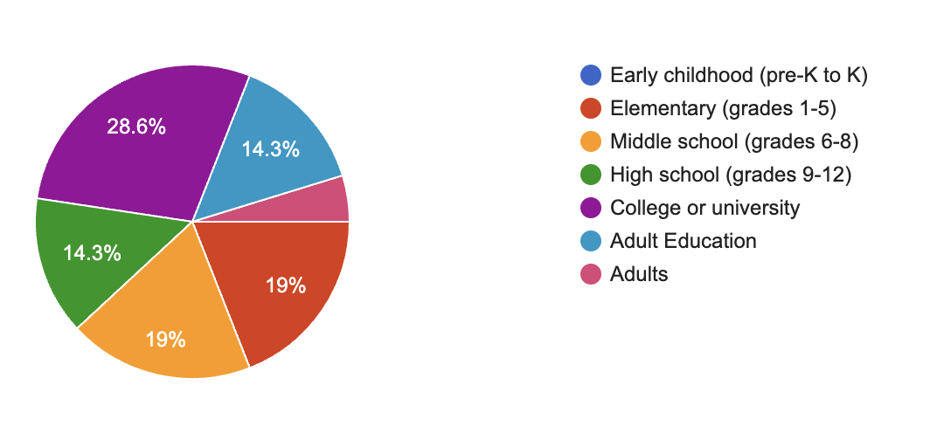
Participants were asked about their target audience in this survey, and the results are as follows:

Figure 1: Responses to Question 1

- Elementary school: 19.0%
- Middle school: 19%
- High school: 14.3%
- College and university: 28.6%
- Adult education: 19.1%
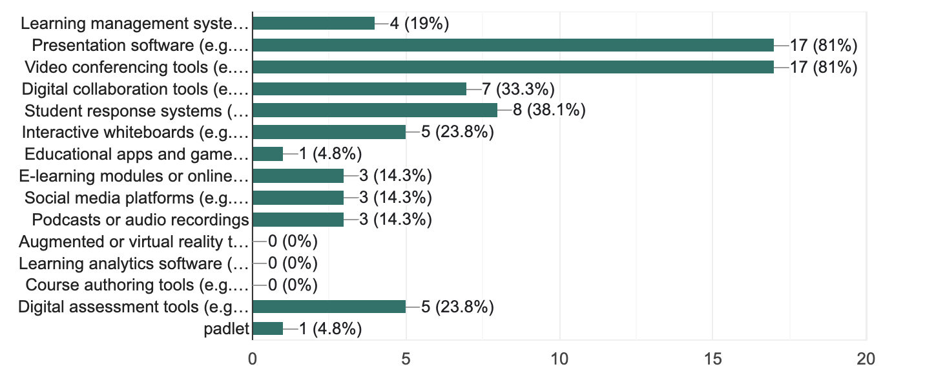

Figure 2: Responses to Question 2
According to the survey results (Figure 2), presentation software such as PowerPoint was the most commonly used technology tool among educators, accounting for twenty-four percent of the total. Video conferencing tools such as Zoom were also trendy, with a usage rate of twenty percent. Digital collaboration tools, student response systems, and interactive whiteboards accounted for eight percent, eight percent, and six percent, respectively. The remaining technologies accounted for four percent or less of the total usage rate. These results indicate that presentation software and video conferencing tools are essential technology tools for educators in today's educational environment.
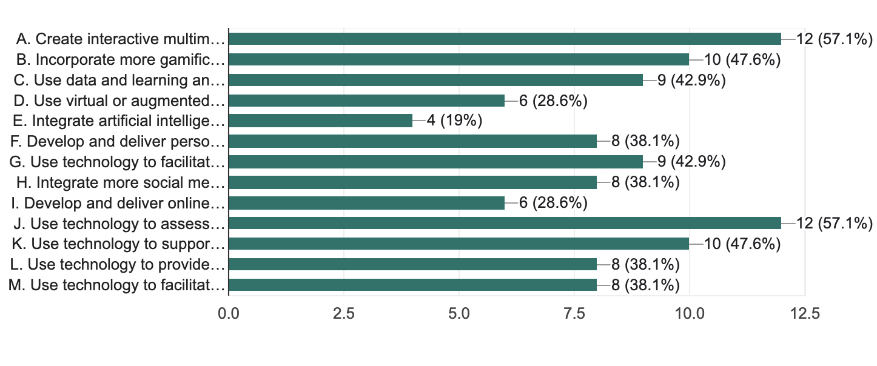

Figure 3: Responses to Question 3
Based on the survey results (Figure 3), the top three technology integration strategies that language educators should focus on are: using data and learning analytics to inform instruction (twenty-three point three percent) and creating interactive multimedia materials for students (twenty-three point three percent). The least mentioned strategies include integrating artificial intelligence or machine learning tools in teaching (six points seven percent) and integrating more social media or digital tools to increase student engagement (six points seven percent).
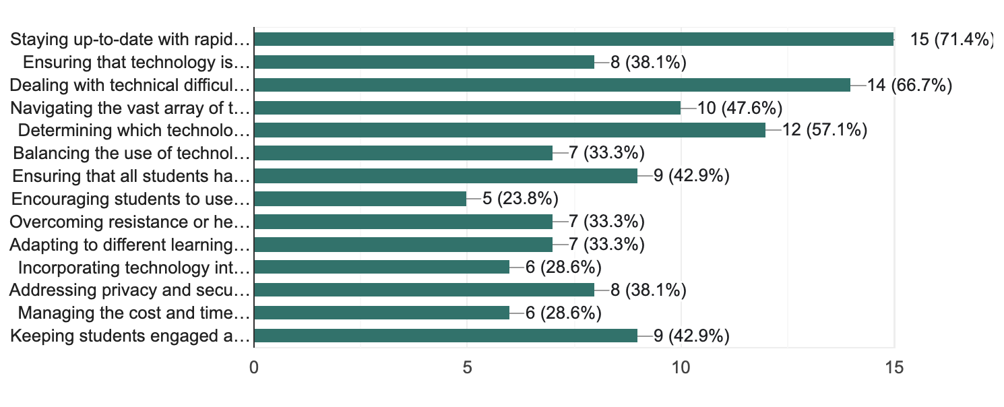

Figure 4: Responses to Question 4
With regards to non-technical difficulties, technology integration and management, which accounts for sixty-five percent of responses, and staying up-to-date by seventy-one percent are the most common challenges (Figure 4). On the other hand, encouraging students and incorporating technology into assessments and grading are the least challenging parts.
Responses to the last question (Figure 5) indicate that forty-eight percent of respondents prefer in-person professional development workshops. Twenty-four percent chose online training or tutorials. Only fourteen percent of the respondents mentioned peer support and collaborative learning opportunities.
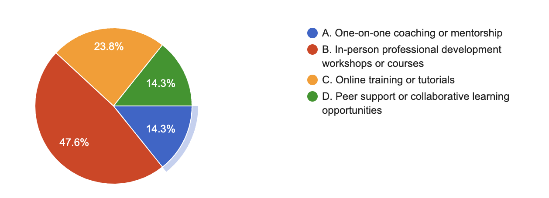

Figure 5: Responses to Question 5

Recommendations
​​Based on the survey results, interactive multimedia lessons, the use of technology to assess more effectively, and the incorporation of gamification into teaching are considered the top three instructional technologies teachers require. The following is a list of recommendations:
- Creating Interactive Multimedia Lessons:
Using Canva, teachers can create visually appealing and interactive multimedia lessons. Teachers can create engaging and motivating infographics, posters, and interactive presentations using Canva. Canva offers a variety of templates, graphics, and fonts that can be customized for each lesson. Teachers can also use Canva to create multimedia handouts and worksheets for students.
- Using Technology to Assess More Effectively:
With Kahoot, teachers can assess their students' learning in a fun and engaging way. Kahoot allows teachers to create quizzes, surveys, and polls for their students to participate. As well as offering real-time feedback and analytics, Kahoot allows teachers to identify areas where their students are struggling and make adjustments accordingly. A teacher can also use Kahoot to gamify assessments by adding rewards, points, and leaderboards to motivate students.
- Incorporating Gamification into Teaching:
Both Canva and Kahoot can be used to gamify learning. Teachers can combine these tools to create interactive quizzes, visually appealing infographics, fun games, and interactive presentations to reinforce learning and test students' understanding. Using Canva and Kahoot can make learning more interactive, engaging, and enjoyable for students.

Links
Here are the links to the survey and other helpful information regarding the recommendations in the previous section.
- Survey: Link
- Survey responses: Link
- How Artificial Intelligence is Changing Education: Link
- Gamification of Learning: Link
- Emerging Technologies and their Impact on Teaching and Learning: Link

References

** All the references related to this report and the professional development session are listed under the “Training Resources” file in the same directory.

